

<date>
For immediate release

Artists Turn their Hand to PSP™ with WipEout PureTM
- Style Icon PSP Attracts Pick Of Young Artists And Designers
- New Game Designs By Burgerman, James, Macfarland & Scien

Cult gaming classic WipEout Pure™, recognised for its outstanding graphics, music and in-game design, comes with a fresh new look to PSP. The highly anticipated futuristic combat racing game from Sony Computer Entertainment Europe (SCEE) is also the first game on the already iconic PSP to attract the attention of leading edge visual artists and designers alongside the music industry.

A new games pack, available for free download from the WipeOut Pure website, will feature new skin, craft and track designs from four of Europe’s most respected visual artists: Jon Burgerman, Mark James, Neil MacFarland and the French graffiti guru Scien.

Each design captures the essence of the artist’s portfolio in a new medium – from Bergman’s animations used by the likes of ‘The Streets’ and ‘Destiny’s Child’, through MacFarland’s illustrations first seen in ‘Sleazenation’ and on ‘MTV’, James’ ‘CardBoy’ project and latest work for ‘Dogs’ to Scien’s street level work in vectoral graffiti around the world.

Scien commented:

“Much of my work looks at redefining the urban space in which we live. Working on a game has been a new experience and one that has allowed me to build as much as to style - and to define from scratch a new urban environment.”

The artists’ work will be available from 1 November 2005 at www.wipeoutpure.com as an Omega download pack including four new tracks, four new ships and four new craft.

The designs - matched with an exclusive urban soundtrack featuring artists including Royksopp and Aphex Twin - make WipEout Pure the PSP game for anyone with an eye for design, an ear for music and a desire to experience interactive innovation.

Contact your local PR manager for artist interviews, original artwork and screen grabs.

ENDS

Notes to Editors:

1] Artists Profiles:

JON BURGERMAN
Burgerman’s work has been widely exhibited in top galleries around the world including New York, LA, London, Hong Kong, Paris and Melbourne as well as published in magazines, books and journals which include The Guardian, Graphic Magazine, Grafik Magazine, Pictoplasma, Stick ‘Em Up and This Is A Magazine. Jon received a D&AD Silver award nomination for his work for Levis, worked on advertising campaigns for Gortex, Snickers and Puma and has had his character animations played at variety of concerts (The Streets, Destiny's Child, Pop Idol USA) and festivals (V festivals, Isle of Wight).

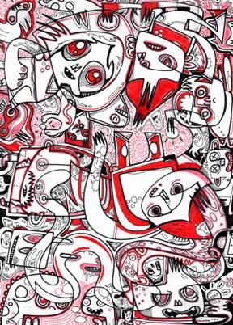

MARK JAMES
London based Mark James works in illustration, product, packaging and identity design. Mark’s work is used across the music, fashion, publishing and advertising industries with a focus on music related projects. Briefs range from designing cover art identities to artist merchandise with projects including packaging for the Super Furry Animals, The Charlatans and most recently Dogs. Marks first and critically acclaimed toy project, CardBoy, was released last year. A mixed media crossover toy, CardBoy boasts an innovative packaging concept that turns into the head of the figure. Mark is currently working on CardBoy Series 2 – a tribute to modern sneaker design and culture. 2005/6 sees more toy projects in the pipeline through UK based design/toy house PlayBeast.



NEIL MACFARLAND
In 1999 Neil began publishing popular comic strips in Sleazenation magazine whilst also being commissioned to illustrate for websites such as Levis and Stella Artois. In 2000 Neil began a four year relationship with Sony Design Europe. This brief included working on mobile phone contents for Sony models J5, Z5 and the next 3 generations. In 2001 Neil was commissioned to create an animated web series, ‘I Will Destroy You’ for play.com. He also produced the animation for Super Furry Animals ‘Rings Around The World’ first DVD album. 2005 has already seen a sold out show at the Best Gallery, London. Neil is currently working with MTV2 Europe, under the series title ‘Head Cheese’, whilst continuing his commercial artwork/design and animation in the revitalised new media industry.



SCIEN [123klan]
Prestigious French graffiti artist ‘Scien’ has painted his way to the forefront of the scene along with his fellow artists in the 123klan. Inspired by Neville Brody’s work in 1993, Scien incorporated elements of graphic design into his work to create vectorial graffiti pieces. This style has led to widespread popularity. Work has been featured in publications such as Wired Magazine (USA), Style Wars (Germany), Design Graphics (Australia) and Xplicit Graffix (France). Scien and 123klan have also been asked to perform live and feature in numerous conferences and exhibitions as well as their own European tour starting in July in association with Carhartt. Examples of collaborations include Marc Ecko’s ‘getting up’ event in New York (2005), Kosmopolite in Paris (2004) and Semi Permanent in Sydney, Australia (2003). Scien’s style has attracted the interest of numerous commercial clients including Scion, Stussy, Mini Cooper, Computer Arts and Carhartt.
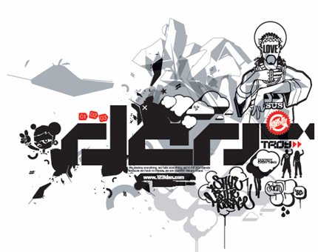

2] About PSPTM(PlayStation® Portable)

PlayStation Portable is a new handheld entertainment system that allows users to enjoy 3D games, with high-quality full-motion video, and high-fidelity stereo audio. With graphics rendering capability comparable to that of PlayStation®2, PlayStation Portable features a 4.3 inch widescreen, high-resolution TFT display. PlayStation Portable also adopts a newly developed compact but high-capacity (1.8GB) optical disc, Universal Media Disc (UMD), as its storage medium. With a wide range of accessories and connectivity options, including Memory Stick Duo™, USB 2.0, IR port and Wireless LAN.

3] About Sony Computer Entertainment Europe Ltd.

Sony Computer Entertainment Europe (SCEE), based in London, is responsible for the distribution, marketing and sales of PS one®, PlayStation®2 and PlayStation® Portable software and hardware in 104 territories across Europe, the Middle East, Africa and Oceania. SCEE also develops, publishes, markets and distributes games software for the three formats, and manages the third party licensing programs for these platforms in the PAL territories. At the end of June 2005, over 40 million PlayStation® units had been shipped across these PAL territories, over 102 million worldwide. Between its European debut on 24 November 2000 and 20th July 2005, over 33 million PlayStation®2 units have been shipped across the PAL territories, over 91 million world-wide, making it one of the most successful consumer electronic products in history. Between the launch of the PSP in Japan in December 2005 and 21 July 2005, over 5 million PSPs have been shipped worldwide.

PlayStation and the PlayStation logo, PS one and PS2 are registered trademarks of Sony Computer Entertainment Inc. PSP and UMD (Universal Media Disc) are trademarks of Sony Computer Entertainment Inc. All other trademarks are property of their respective owners.

More information about PlayStation products can be found at http://www.scee.com , www.yourpsp.com and www.playstation.com. or visit the Virtual Press Office at www.scee.presscentre.com.

